

***School of Mechanical & Manufacturing Engineering (SMME), National University of Science and Technology (NUST), Sector H-12, Islamabad***

***Orthographic Projections on AutoCAD Mechanical***

Bazla Tariq

460547

School of Mechanical and Manufacturing Engineering, NUST

AE 103: Engineering Drawing & Graphics

Lab Engineer Laiba Waheed

# *Drawing number: 1*

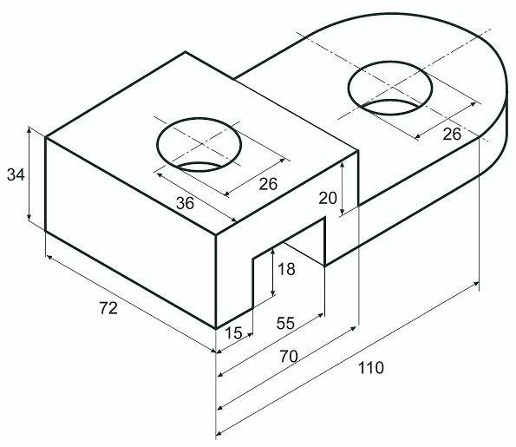

# *Orthographic Projections:*

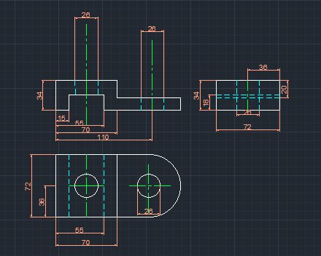

# *Drawing number: 2*

## *Orthographic Projections:*

# *Drawing number: 03*

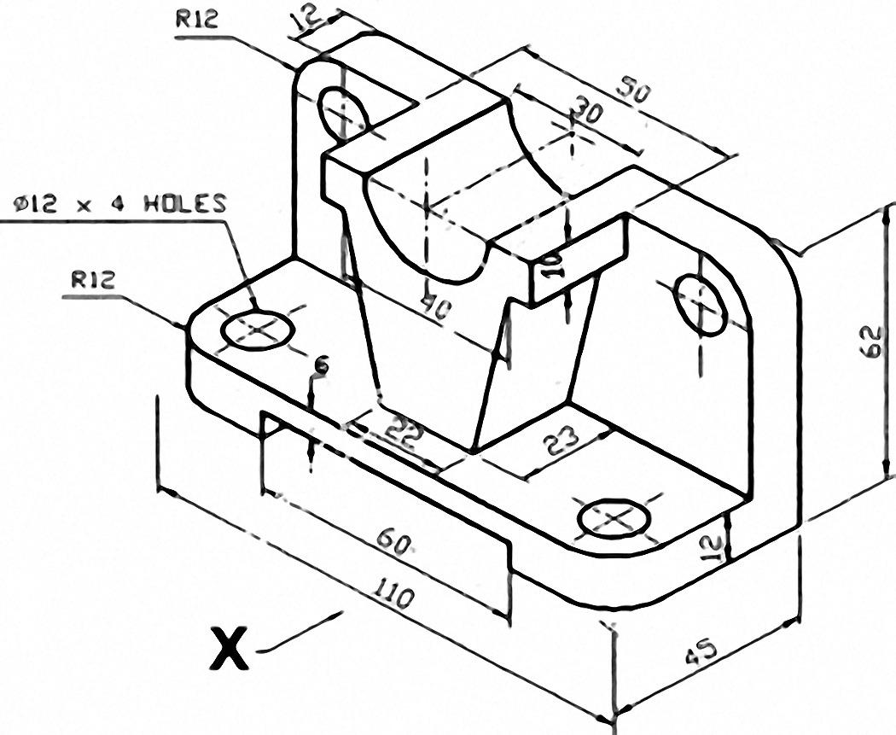

# *Orthographic Projections:*

